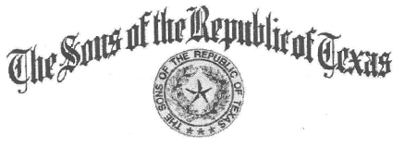
Chapter President Chapter Secretary

Steve Manis Clark Wright
Chapter Vice President Chapter Treasurer
Ronnie Schoolcraft Mike McCown

Sidney Sherman Chapter #2

Minutes of the meeting of the Sidney Sherman #2, Sons of the Republic of Texas

The Sidney Sherman Chapter #2, Sons of the Republic of Texas met at Kelley's Family Restaurant in Texas City March 15 between 6 and 8 P.M.

All officers (Steve Manis, Ron Schoolcraft, Clark Wright and Mike McCown) attended this meeting. Ron Schoolcraft opened the meeting with a prayer, and led us in the pledges to the American and Texas flags.

Members attending were: Gus Mannis, Steve Mannis, Ron Schoolcraft, Mikel Manis, Clark Wright, Michael McCown, Steve Mannis Jr, Steve Mannis III, Hunter Mannis, William McLaren, Mike Mitchell, Albert Seguin (Carvajal Gonzales), Mike Mize, Billy Mayo, Stephen McCreery Jr, Matt Kane, not registered: Tom Green & Ron Brown

Guests were:
Chailee Manis, Sue McCown, Trichel Manis

Prospects were:
James Cantrell, J.B. Kline

Tom Green began the evening by installing the 2016 officers: Steve Manis: President, Ron Schoolcraft: Vice-President, Clark Wright: Secretary and Mike McCown: Treasurer. Ron Schoolcraft called on Chaille to present the badge of Chapter President to her husband, Steve.

After recognizing our guests, the Secretary (yours truly) read the minutes of the January meeting. Our Treasurer, Mike McCown, gave his report covering the three months and President Manis reported on this day in Texas History. He continued by reporting on projects and our calendar.

Our speaker having been delayed in Houston traffic, Ron Schoolcraft introduced Tom Green who agreed to present a history of Sam Houston, reciting some stories we would recognize, and providing a number of story, making his talk on Houston.

Our supper was served during this time.

We closed the meeting with benediction from Tom Green.

Respectively submitted, Clark P. Wright

